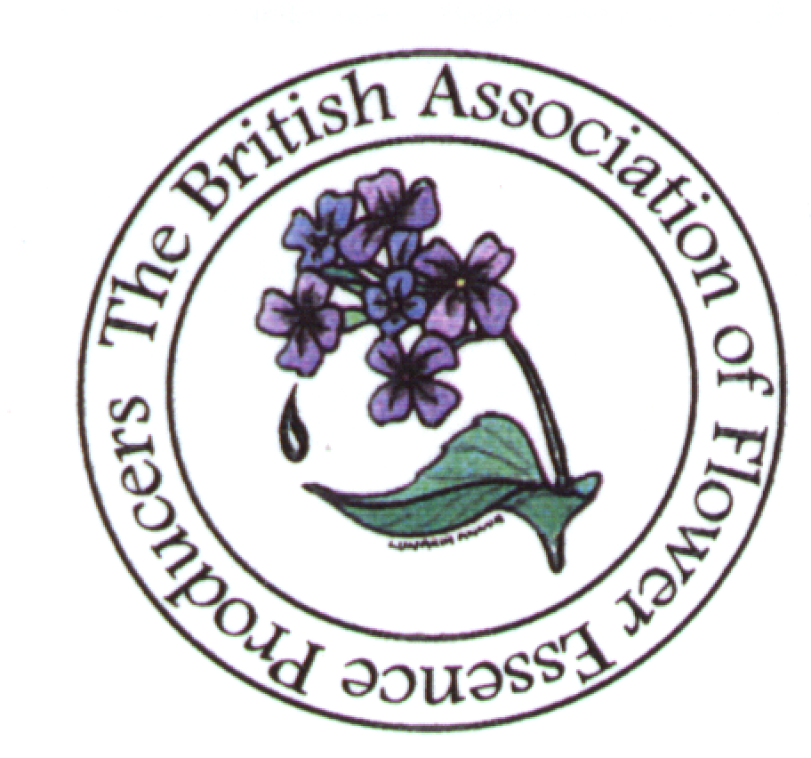

The British Association of Flower Essence Producers

Welcome to BAFEP!

The British Association of Flower Essence Producers (BAFEP) is the trade association for producers of Bach Flower Remedies and other types of Essences. It sets and maintains standards of production, labelling and advertising in accordance with the guidelines as laid down by various UK governmental agencies. BAFEP also keeps abreast of the ever-changing politics within both the UK and EU that concern essences both now and in the future. For the general public BAFEP provides a listing of over 50 essence producers that abide by BAFEP standards and are entitled to use the BAFEP logo in their literature and labelling.

Formation
In 2000 it was recognised that the amount of pro-active effort that was needed to protect the future of essence production and essence use in the UK would distort and weaken the broad role of the British Flower and Vibrational Essences Association (BFVEA). It was agreed that a sister association, the British Association of Flower Essence Producers (BAFEP), should be formed to take over that role.

On 28th September 2000 BAFEP was born. One of the first tasks was to disseminate guidelines of production, labelling and advertising that were already part of UK law. This is made freely available to anyone enquiring.

Meeting with the MCA ( now known as the Medicines & Health Products Regulatory Agency)
To help clarify the essence situation in the UK, a meeting with the Medicines Control Agency (MCA) was set for June 2002. This was a most productive session as BAFEP was able to give the full picture of essence production in the UK, the breadth of which had not been appreciated by the government. It became apparent that there were more issues around the production of Bach essence ranges and that these would create very specific issues that would need addressing.

Essence Survey Results 2003
With that in mind, BAFEP commissioned a survey of all essence production in the UK
While the methodology traditionally used in the production of Bach Flower Remedies is well documented [ see E. Bach Twelve Healers & Other Remedies 1936 C.W.Daniel, Weeks & Bullen, Bach Flower Remedies Illustration & Preparation, 1964 C.W.Daniel] other methods have been developed which related directly to the original process.

As moves continue within the EC to bring many herbal preparations and similar items under various directives BAFEP realised it would be useful to confirm and prove how essences are made in the UK. To confirm that essences are still made following the guidance laid down by Dr Edward Bach in 1936; to confirm the stance that essence producers have taken proposing that essences are not homoeopathic, not herbal but have a category of their own, most closely aligned to food or living water; to prove the last two by surveying and collating information from the main producers in the UK.

All BAFEP members, the larger producers linked to the British Flower and Vibrational Essences Association and Mount Vernon/ NelsonBach were all approached – 40 in all. Of the surveys 37 were returned. No response was received from the Bach Centre, Mount Vernon. A very brief response was received from NelsonBach that referred BAFEP to the British Homoeopathic Pharmacopoeia. This was of little use since the Bach Flower Remedies were removed from there a few years ago after homoeopaths agreed that they were not homoeopathic preparations. A further request for confirmation of their current methods of dilution has not elicited a response to date.

BAFEP was able to confirm that most essences are still made following the guidance laid down by Dr Edward Bach in 1936. Essences produced by those surveyed are not homoeopathic and not herbal. They could have a category of their own if it was feasible, but essences remain most closely aligned to food or activated/living water.

The survey is on-going, with all new BAFEP members completing the questionnaire.

Developments in 2004
Boots the Chemists took on a new flower essence range (Balancing Blooms). The producer of this range was subject to a lot of ‘interest’ from Trading Standards (TSO) and the Food Standards Agency (FSA) initiated by pressure from a competitor. This precipitated considerable examination from Trading Standards, the Foods Standards Agency, the Public Analyst and the Medicines and Health Products Regulatory Agency concerning the nature of essences and whether they are best classified as medicines or foods. The consensus is that essences are indeed foods, although Trading Standards confirm that they are also ‘not medicines’. The MHRA position is that only they can dictate what is a medicine and what is not a medicine. So it appears that there is still some way to go before a clear definition of essences emerges, according to Law.

The desire by one large manufacturer who currently market their products under a PLR to continue to market their Bach Flower Remedies throughout Europe has led to discussion with the MHRA as to the feasibility of this under the THMD. The latter ‘catch-all’ directive is designed to mop up all remaining medicinal products (particularly herbals) sold that wish to continue to be marketed as such. In future the food directives will preclude all foods from making psychological and physical claims which could potentially jeopardise essence marketing after its implementation.

Ironically complaints raised against Balancing Blooms have engendered a more beneficial situation than previously envisaged. The FSA and TSO accept Bach Flower remedies as foods and are willing to allow claims for the original plants used in the preparation (as opposed to indications for the actual product itself).

This is very fortunate as registration under the THMD, although possible, is expensive and inappropriate. Akin to bashing ‘a square peg through a round hole’, it would create intolerable restrictions on which essences could be marketed and which essences were made, especially from uncultivated species in the wild.

It would also incur expenses and resources far beyond the reach of small essence manufacturers. A full manufacturing license, including employing a Qualified Person and accumulating all the requirements of Good Manufacturing Practice that BAFEP members have accomplished more realistically using HACCP plans.

The irony about what is a medicine still abounds. When we approached the then MCA in 2002 they insisted that whereas their business was to grant licenses and regulate manufacture it was not their job, but rather the manufacturers, to decide whether a product was a medicine or not.

However Bach Flower Remedies and other essences are clearly borderline and could be marketed as foods or medicines. Their hackles were raised by the TSO deciding that the Bach range were clearly foods and that the grey area between medicines and foods was misleading for consumers. This may well change the situation in which that large company market essences as medicines and everyone else markets them as foods.

Developments in 2005/2007
The MHRA stated in early 2005 that registration for Bach Flower Remedies under the THMD was ‘implausible’. With further development with Foods Directives within the EC, BAFEP has had a meeting with the FSA and MHRA in late August ensure a safe ‘home’ for all essences within UK law. We were advised to carry out research to back the emotional/psychological claims for our essences. This has being undertaken.

Developments in 2014

Nutritional labelling for any bottle or package where the area that could be labelled is 25cm ² or above is mandatory from December 2016. For most essence producers this will be necessary for bottles above 10mls.

We have now ascertained from the Foods Standards Agency that the requirements for nutritional labelling should look like this:
Nutrition
Energy per 100ml

XXXkj/YYYkcal

Nutrition
Energy per 100ml

XXXkj/YYYkcal

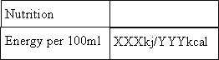
Nutrition
Energy per 100ml

XXXkj/YYYkcal

The additional phrase needs to be outside the table/box:
“Contains negligible amounts of protein, fats, saturates, carbohydrates, sugars and salt”

The values for alcohol dilution can be obtained from the graphs that are held in the members’ section of the BAFEP website.

If glycerol or other preservative is being used calculation can be made from the calorific values on the manufacturer’s label.

Full copies of the legal requirements, EU legislation etc can be found on the members’ section of the BAFEP website.

Tony Pinkus (Chair) & Sue Lilly (Secretary) December 2014

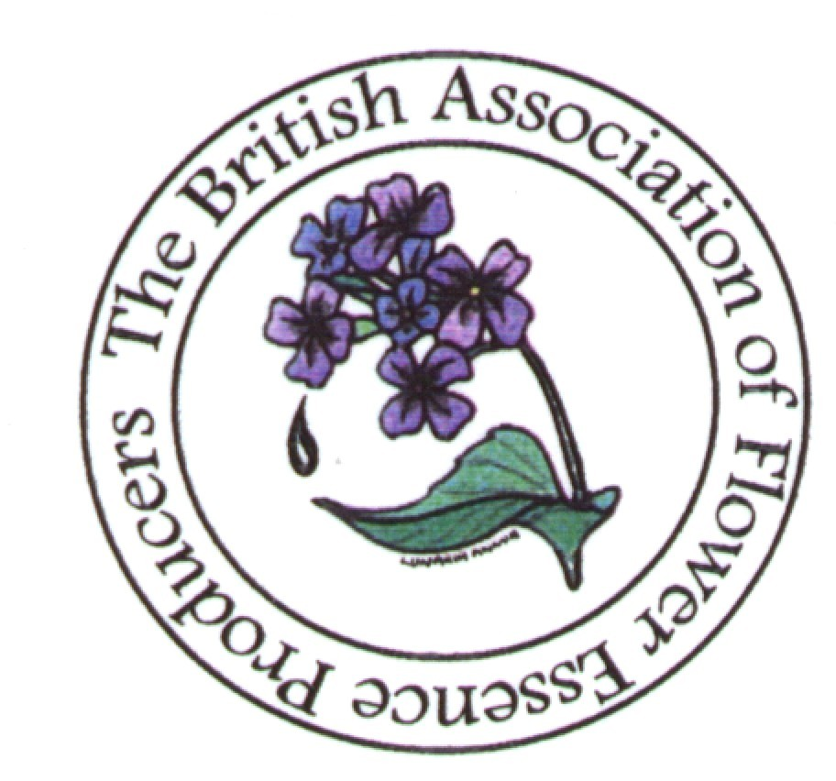
This is a survey of how flower and vibrational
essences are made.

It is being undertaken by BAFEP to determine the various methods used to prepare essences.

This is all producers including Tree, Fungi, Grass, Gem, Colour, Bach, Flower, Channelled etc.

Please complete and post back to BAFEP in with your application.

All replies will be added to the results in early 2003 to provide additional back-up to the position paper on U.K. essence production that was published then.

Please answer all questions even if you need to append further information to clarify your answer.

A tick in the bracket [ ] affirms “yes”, please tick all that apply.

Using the listing of the Brazilian Protocol 1998/9, can you indicate which categories cover the essences you produce?

1. Flower Essences – made using water/sunlight [ ]
- made using water/moonlight [ ]
- using a mediator (i.e. a crystal, plant spirit) [ ]
- using a boiling method [ ]
- other please specify………….

2. Plant Essences (the fruit, root, stem, twig, seed etc of a plant) [ ]
- using sunlight/water [ ]
- using moonlight/ water [ ]
- using a boiling method [ ]
- other method, please explain….. [ ]

3. Mineral, Crystal or Gem Essences [ ]
- using sunlight/water? [ ]
- using moonlight/ water? [ ]
- other method, please explain….. [ ]

4. Environmental Vibrational Essences [ ]
- using sunlight/water [ ]
- using moonlight/ water [ ]
- other method, please explain….. [ ]

4b. Channelled Essences [ ]
- you focus and channel the energies? [ ]
- a mediator is used (guide etc] ? [ ]

5. Radionic Essences [ ]
- pendulum? [ ]
- ‘Black box’ or similar? [ ]
- other device? [ ]

6. Combinations of any of the above in one making [ ]
please specify . . . . . .

6. General Essences (ones that do not fit into any of the above) [ ]
Please can you explain what you do?

Dilutions:

We are taking a standard line that 30mls of brandy = 1000 drops
To ensure explanations are clear, please complete the diagram on the last page, to clarify how your dilutions are made.

1. The liquid that results from the original essence-making is generally called the ‘mother’ essence. Do you use this term? [ ]

If not, what do you call it?

Do you preserve this? [ ]

What preserver do you use?

2. If you use alcohol, what is the proportion of alcohol/mother essence in this preserved mix?

Diluting Further

3. Do you call the next dilution ‘stock’? [ ]

If not, what do you call it?

4. How do you make this dilution (number of drops to bottle)?
……. Drops in a 10ml bottle
……. Drops in a 15ml bottle
……. Drops in a 30ml bottle

5. Do you sell this dilution? [ ]

6. Do you dilute this ‘stock’ further for sale? [ ]
How do you dilute further (drops in bottle)?

7. Do you sell this dilution? [ ]

What do you call it?

8. What in your opinion is the dilution of your essences that you regard as the last before the essence is of no use?

9. How many dilutions is this away from the ‘mother’ essence?
(mother essence is 1, stock is 2 etc)

10. Do you label your essences that are sold - as - ‘stock’ [ ]
- dosage [ ]
- 1:240 [ ]
- 1:400 [ ]
- 5x [ ]
- 4x [ ]
- 1:240% [ ]
- other – please explain [ ]

- Could you indicate here how many single essences in each category you make as part of your essence range (s):

Flower . . . . . . . . . . . . . . .
Plant . . . . . . . . . . . . . . .
Water . . . . . . . . . . . . . . .
Mineral/Crystal/Gem . . . . .
Environmental. . . . . . . . . .
Channelled . . . . . . . . . . . .
Radionic . . . . . . . . . . . . . .
General . . . . . . . . . . . . . . .
Other . . . . . . . . . . . . . . . .

12. It would be helpful if you would add your name and address here + the name of the range(s) of essences which you prepare. Then we can contact you to verify any details from the questionnaire if necessary.

13.

Diagram representation of how your dilutions are made
(based on 30ml bottle for sale)

You not need to complete both here, unless you have more than one method. Only complete as many boxes as you need to describe what you sell, indicating what percentage or number of drops goes into each as appropriate. Please cross out unused images out to avoid confusion. Please make it clear which one(s) is offered for sale.

1.

A

A - This represents the
liquid you start of with. E.g
In a sunlight/flower method
This is the liquid from the
bowl that held your flowers
and water

2.

A

A - This represents the
liquid you start of with. E.g
In a sunlight/flower method
This is the liquid from the
bowl that held your flowers
and water

Thank you for completing the survey. Please return to BAFEP with your membership form.

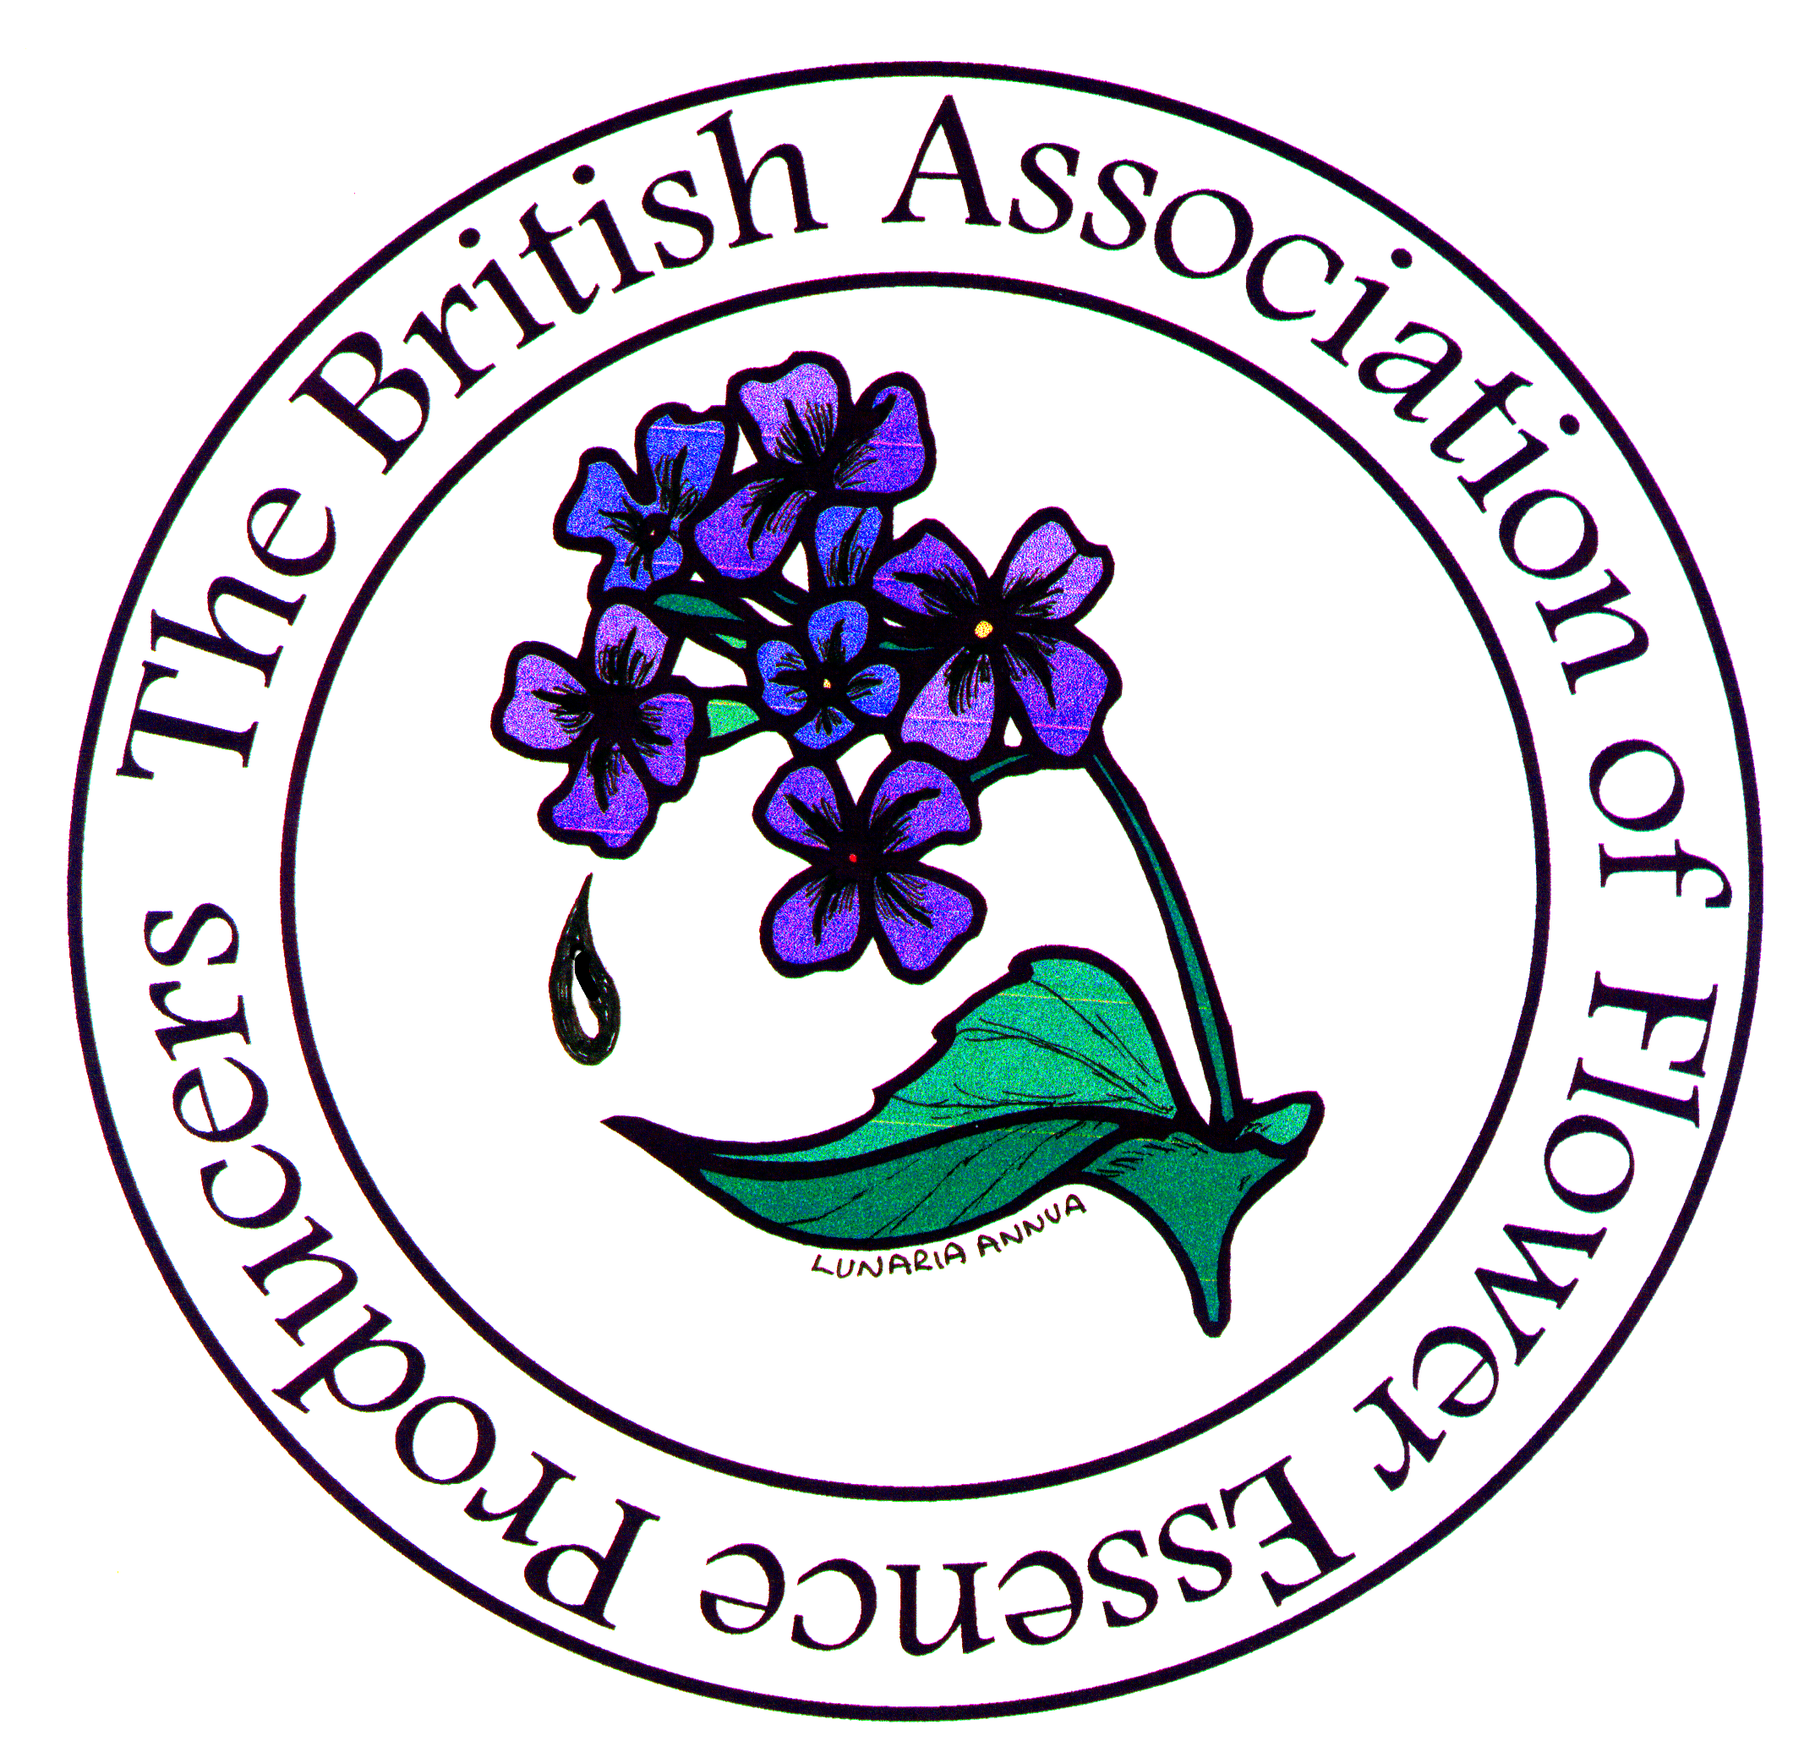
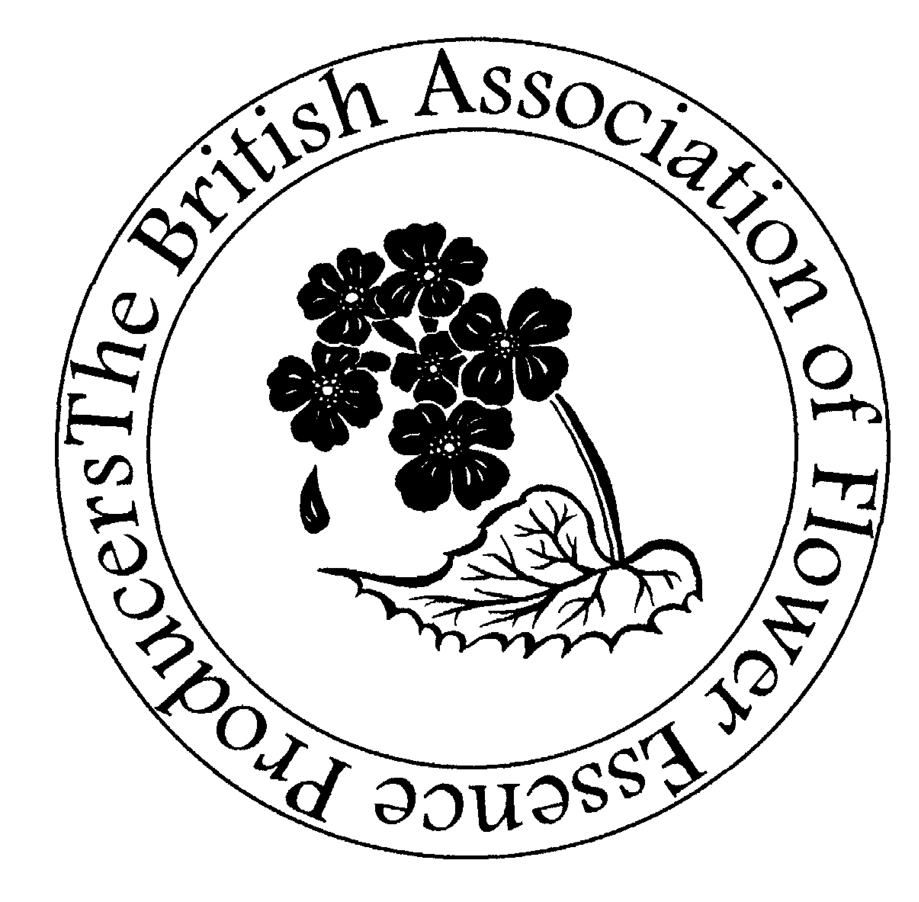

The British Association of Flower

Essence Producers

Record of Production Procedures

Please complete this as fully and factually as possible.
You may be asked to complete a new form each year to verify your production situation. This form is a record of that.
You are required to comply with the UK food regulations, MHRA Guidelines, DEFRA labelling law and to implement some type of HACCP procedure.
(This also applies to Non-UK producers whose essences are imported into the UK)
If your response to any items indicates that action is needed to meet BAFEP membership requirements, this will be explained to you and
you will be offered help.

On receipt of this form and acceptance of your membership you will be given a Username and Password for the members section of the website, the small logos (Mono and colour,

as tiff and jpg files) are available on there

1. NAME OF ESSENCE RANGE:

2. NAME OF PRODUCER or PERSON RESPONSIBLE FOR PRODUCTION:

3. LABELLING LAW:

Please affix a sample of your labels here (30mls if you do one, would be ideal):

4. PRODUCTION:

a) Do you hold a food hygiene certificate or equivalent? Yes  No 

b) Do you operate a HACCP Procedure or similar? Yes  No 
If “Yes” please go to Item 5
If not, continue with Item 4

c) Production checks – please tick the box of those you operate.

Do you sterilise bottles? Yes  No 

If you do not sterilise bottles, do you record the seals of your bottles packaging?
Yes  No 

Do you record the batch dates of your preservative? Yes  No 

Do you do a visual check of your preservative or filter it? Yes  No 

Page 2

What dilution of preservative do you use?

Less than33% preservative 

Around 50% preservative 

Around 75% preservative 

Nearly 100% preservative 

Do you use tamper-evident bottle tops or shrink-on seals? Yes  No 

Do you use “Batch Numbers”? Yes  No 

Do you show expiry dates/best before dates? Yes  No 

Do you have a dedicated space for your bottling? Yes  No 
(A separate room, with 2 sinks, water, storage, suitable work surfaces etc)

Do you store samples of each batch as a stability check? Yes  No 

Do you keep a visual, actual or written record of the sources of each batch of mother essence? Yes  No 

5. LITERATURE

Please enclose samples of your HACCP procedure and your essence literature or catalogue and the address of your website if you have one.

6. Other Information

Please also enclose 125-150 words for the website and hardcopy listing, plus a copy of your logo (hardcopy or jpg)

Signed: Date:

Please return to:

BAFEP, ‘Llanddewi’, Cefn Gorwydd
Llangammarch Wells, Powya
Wales, UK, LD4 4DN

British Association of Flower Essence Producers
‘LLanddewi’
Cefn Gorwydd, Llangammarch Wells
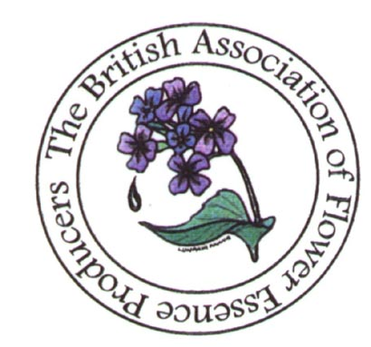
Powys, Wales, UK, LD4 4DN
BAFEP Application Form

[Office use only—membership No:_____ ]

Name of Essence Range(s):

Types of Essences (Flower, Plant, Environmental, Channelled etc):

Name of main producer:

Name of person or company responsible for marketing:

Contact Address:

Tel No (inc code) :Fax No (inc code):

Email:

Website:

UK Members are required to abide by the Constitution, which published is on the website and adhere to
UK laws as outlined in the BAFEP Guidelines (an updated version is on the website).
Non-UK members are expected to adhere to the laws of their own country, but to be advised that when selling essences in the UK, those essences are subject to UK /EC law

Confirmation of membership will be sent on return of this form and the enclosed
questionnaire. The Constitution is available from the above address on request.

I/We enclose a sterling cheque or a cheque to equivalent to the sterling amount*
for ______ payable to BAFEP, for our membership until the end of December 2013.
(You can pay via PayPal, direct to: info@bafep.com)

Signed: Date:

Membership rates (please choose the most appropriate for you) :
Large business (over 100K turnover) : £250-£500 pa
Medium sized business (under 100K turnover): £100—£250 pa
Small business (under 60K turnover: £50—£100 pa
Very Small /New business (under 5K turnover) - £25 pa
(* please add £2.50 if sending a non-sterling cheque to cover bank charges)
British Association of Flower Essence Producers

PO Box 6
Exminster
Exeter
Devon
EX6 8YE
email: info@bafep.com
Web: www.bafep.com
Secretary : Sue Lilly
Tel: 01392 832005
email: info@bafep.com
Web: www.bafep.com
Secretary : Sue Lilly
Tel: 01591 610792
BAFEP Application Form

[Office use only—membership No:_____ ]

Name of Essence Range(s):

Types of Essences (Flower, Plant, Environmental, Channelled etc):

Name of main producer:

Name of person or company responsible for marketing:

Contact Address:

Tel No (inc code) : Fax No (inc code):

Email:

Website:

UK Members are required to abide by the Constitution, which published is on the website and adhere to
UK laws as outlined in the BAFEP Guidelines (an updated version is on the website).
Non-UK members are expected to adhere to the laws of their own country, but to be advised that when selling essences in the UK, those essences are subject to UK /EC law

Confirmation of membership will be sent on return of this form and the enclosed
questionnaire. The Constitution is available from the above address on request.

I/We enclose a sterling cheque or a cheque to equivalent to the sterling amount*
for ______ payable to BAFEP, for our membership until the end of December 2020.
(You can pay via PayPal, direct to: info@bafep.com)

Signed: Date:

Membership rates (please choose the most appropriate for you) : Signed: Date:

Membership rates (please choose the most appropriate for you) :
Large business (over 100K turnover) : £250-£500 pa
Medium sized business (under 100K turnover): £100—£250 pa
Small business (under 60K turnover: £50—£100 pa
Very Small /New business (under 5K turnover) - £25 pa
(* please add £2.50 if sending a non-sterling cheque to cover bank charges

